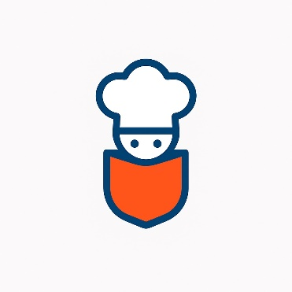**Pocket Chef**

GCA1 IoT – Dylan Smyth, Joshua Donnelly, Luke Clarke

**Introduction**

In this project we will discuss what our project is? why this project? And how are we going to achieve our goals. We outline what hardware we will be using, and how they will be implemented in the final project. We showcase our early prototype and detail how we adapted that prototype as a result of feedback from our testing.

**What is Pocket Chef?**

Pocket chef is a tool for inexperienced cooks, such as students, to learn the difficult but necessary skill of cooking. Cooking can be dangerous, so we have decided to focus on helping specifically with high-risk food (e.g. Chicken or pork). Pocket Chef connects with a thermometer through a connection with the Raspberry Pi over Flask. The application is simple and intuitive, but informative and helpful.

Hardware List

(Luke Clarke)

The hardware that will be required to develop this application:

1. Raspberry PI
2. Li-polymer battery PI HAT
3. Li-polymer battery -> if not included in HAT type
4. Led
5. Male / Male connector
6. Male / Female connector
7. Female / Female connector
8. Female Jack Male Plug Panel Mount
9. Waterproof Thermometer

10. Breadboard

**Total: roughly 60€**

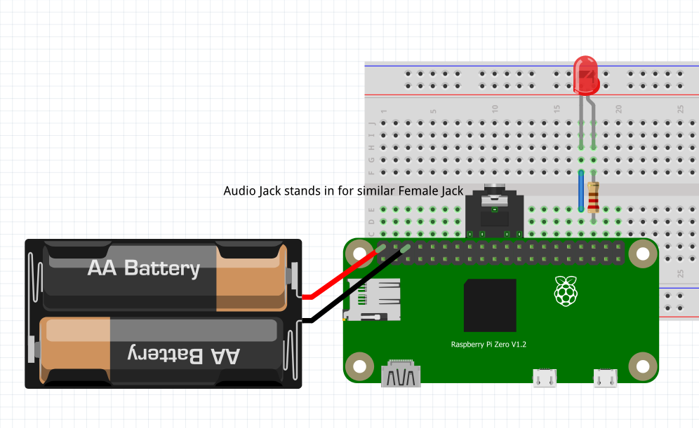Rough Pi Zero breadboard schematic:

Data, Data Storage and Data Processing

(Dylan Smyth)

**Data Gathered by Sensors**

Our IoT cooking system uses a Bluetooth thermometer connected to a Raspberry Pi. The thermometer measures the internal temperature of meat during cooking and the Pi acts as a bridge between the thermometer, the Internet and the database. The system may also use a camera module for photo-based doneness detection but we will try to use the users phone if possible.

1. **Bluetooth Thermometer**

* Data collected:
  + Internal meat temperature
  + Battery level of the thermo
  + Timestamp of each reading
* How it works:

The thermometer uses a thermistor sensor inside the metal probe. A thermistor changes resistance with temperature. The onboard chip converts this change into a digital temperature reading and sends it over bluetooth to the Raspberry Pi.

* Frequency of readings:
  + Default: 1 reading every 5 seconds
  + High accuracy mode: 1 reading every 1 second
  + Low power mode: 1 reading every 30 seconds – 1 minute for slow cookers
* Sample data format:

{

device_id: Dylan’s Pi,

thermometer_id: bluetooth_thermometer,

temperature_c: 63.5,

battery_percent: 80

}

2**. Raspberry Pi Camera Module**

* Data collected: Photos of the meat’s surface during cooking to visually detect rawness of the meat.
* How it works: The users takes a picture of the meat inside and out and it gets compared to photos in the database to confirm if its cooking right or done.
* Frequency of capture:
  + Whenever the internal temperature rises by 5°C
  + User is pinged to take photo if they don’t know if meat is cooked or not
* Stored data:  
  Each photo is stored with a timestamp and associated cooking session ID.

1. **Third-Party API Data**

* Data collected:
  + Recommended cooking temperatures
  + Recipe details and images
* Source: Third-party cooking/food safety APIs (BBC Foods)
* Use: These are stored in the local database and used to give the user guidance on safe cooking temperatures for specific meats.

**Data Storage**

All sensor data and cooking records are stored in a MySQL relational database. MySQL is used because it provides data integrity, supports structured queries. It is also the database software we are most familiar with.

Project Persona

(Dylan Smyth)

**Persona 1: The Student**

**Name**: Emily Byrne

**Age**: 19

**Background**: First-year university student living away from home for the first time in student accommodation.

**Cooking Experience**: Very little experience relies on takeout and microwave meals.

**Goals**:

Learn basic cooking to save money.

Avoid undercooking food as a safety concern.

Follow very clear step-by-step instructions and photos

**Negative Points**:

* + Easily overwhelmed by recipes with too much info.
  + Struggles to tell if food is fully cooked.
  + Limited tools in a small student kitchen.

**How the App Helps**:

Uses the thermometer and example photos to confidently know when chicken, pasta or rice is ready.

Gets visual assistance from the photo system is this chicken is safe to eat.

Learns cooking through guided videos/photos instead of long explanations/recipes.

Security and Privacy

(Dylan Smyth)

**Introduction**

To make sure our IoT cooking system is secure we are also focusing on protecting the Raspberry Pi the Bluetooth thermometer and the data being sent and stored.

**Device Security**

For the device itself only authorised users can access the Raspberry Pi. SSH will be used with key-based login so random people can’t just connect to it. The Bluetooth thermometer will only connect to the Pi it’s paired with (using a secure pairing code). I’ll also make sure the Pi system and any software are updated regularly so there’s less chance of hacking through old bugs.

**Third-party Security**

When data is being transferred it’s protected in a few ways. The Bluetooth connection uses built-in encryption (Bluetooth 4.2+), so no one nearby can read the temperature data. When the Pi sends data to the server or database it will use https with encryption. This keeps things like the cooking history or meat temperature private and stops anyone from changing the data while it’s being sent. Any third-party API calls like to BBC Foods will also go through https.

**Data storage**

For data that’s stored, the MySQL database will be protected with strong passwords and restricted access. Important data such as user IDs or cooking records will be encrypted . Only the system and admin accounts can write or read sensitive data. Backups will also be encrypted and kept safe in case the system crashes or gets corrupted.

**Privacy**

We’re also thinking about privacy. Only the info that’s needed for the system to work will be collected like temperature, battery level and maybe a photo of the meat. Nothing personal will be stored unless the user makes an account. Users will also be told what data is being used.

**Conclusion**

These steps should make sure the system and data secure during transfer, use and while it’s stored in the database.

The UI, User and Testing

(Joshua Donnelly)

**Ui Mock-up**

**Screen 1**

The landing page. Consists of a simple straight forward, with a choice between the high-risk meats that we have decided to focus on. It’s important for all of these screens to follow our usability guideline, Simple and intuitive.

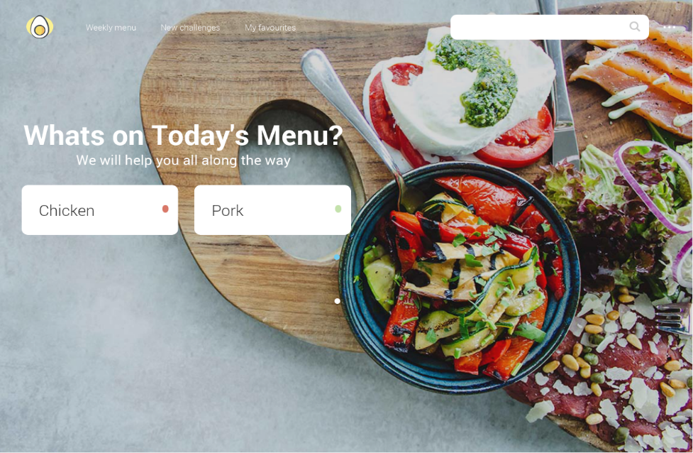

**Screen 2**

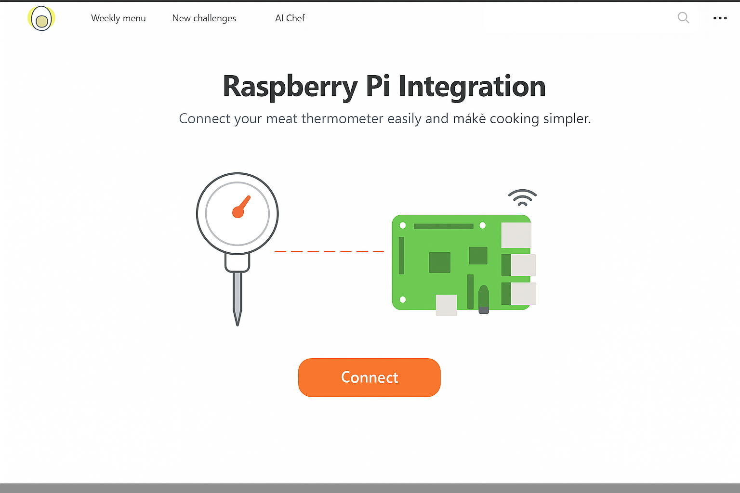App responds with this screen once meat is selected. The user is requested to connect the necessary hardware. The design is simple and clear what is requested from the user.

**Screen 3**

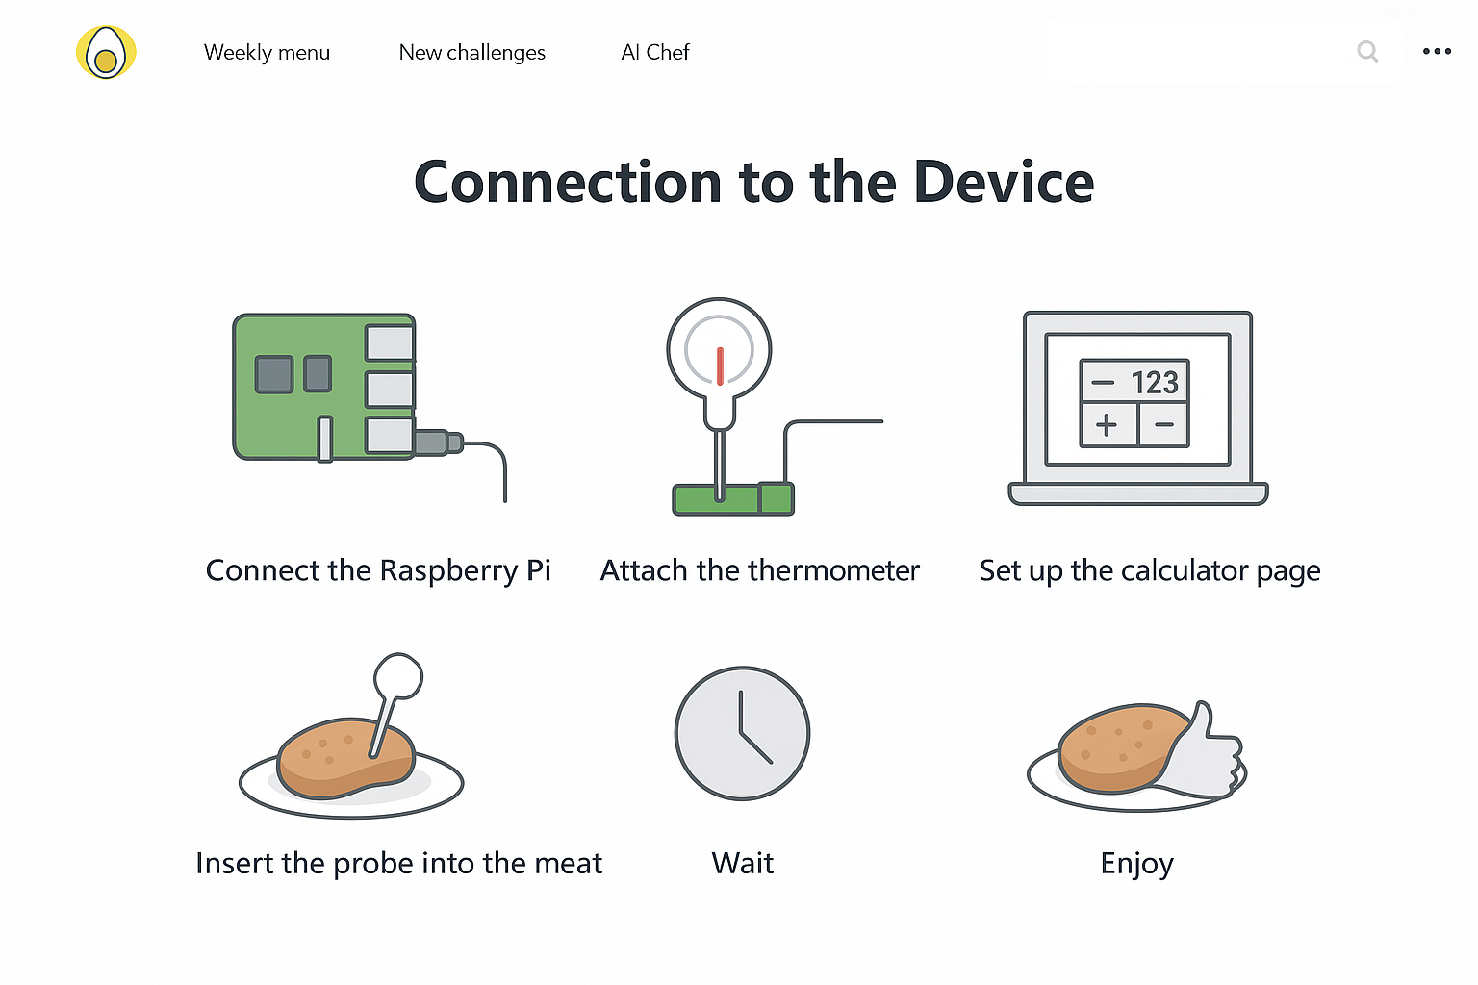Continuation from screen 2 when user clicks “Connect”. Details how the user interacts with and connects to the necessary hardware. Such as the thermometer and Raspberry Pi application.

**Screen 4**

Once the user is shown how the device connects, they can choose whether to connect now or browse the application without set up. Either way they can view the recipes screen, with recipes scraped from BBC Good Foods. Users can add these recipes to their favourites.

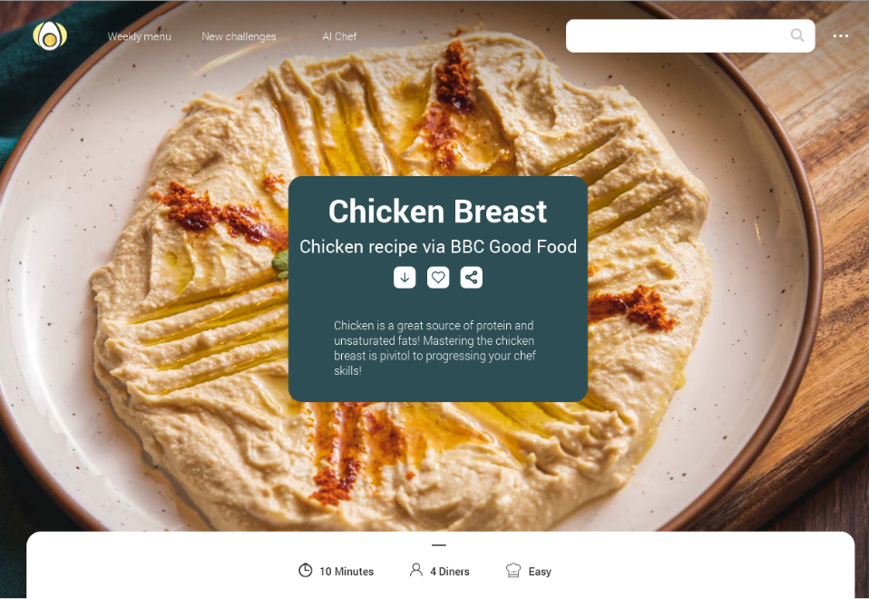

**Screen 5**

Once a user selects a recipe or cut of meat, they will input the weight of their chicken and whether to use a metric system or imperial. They choose when to start the timer (which is calculated by the app).

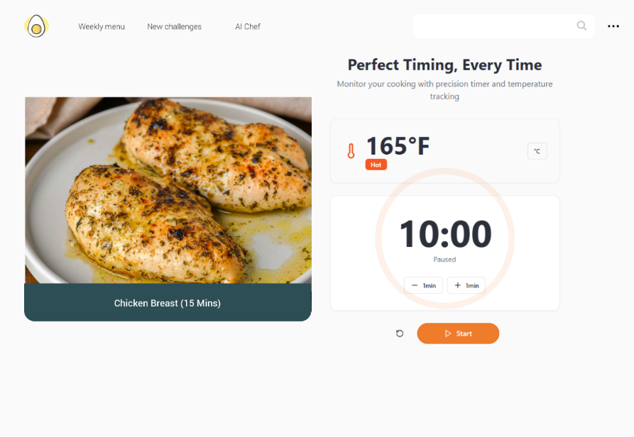

**Screen 6**

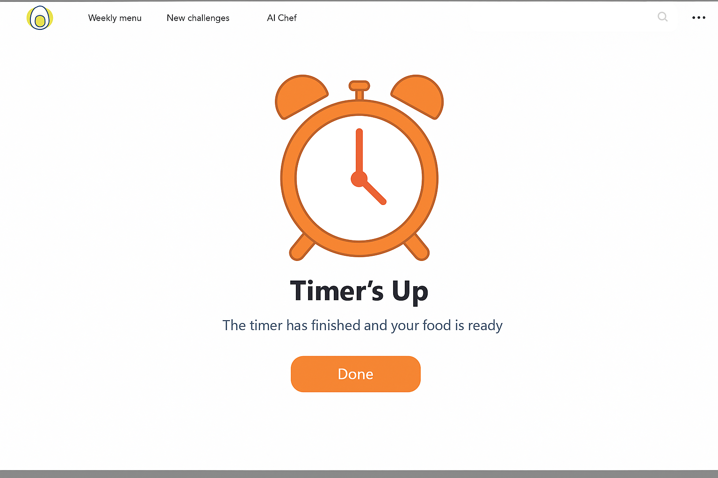Once the timer has finished, the user is notified that the food should be ready.

**Who is this app for?**

The app is designed for inexperienced chefs, such as students leaving home for the first time to live in student accommodation. It’s important to be as simple and intuitive as possible, but with the benefit of most students having average to above average technical literacy. Another persona that is considered in our design is the Culinary Student. These students are unique where they are looking for perfecting their art in cooking proteins. They will push the program to the limit, and dial in the equipment to cooking perfect, juicy chicken.

**What does success look like for Pocket Chef?**

Success for Pocket Chef would be an application that reads real-time information from a thermometer, calculates perfect timing for high-risk foods and results in “properly cooked” end products. The program should also read data from BBC Good Foods, to be displayed on the application, with the option for “Favourites”. We would love to see an inexperienced chef, use our application to build confidence in the culinary arts.

**Testing**

1. **Hardware**

* Thermometer temperature test. Compare the results from the thermometer used in the project, with an actual commercial-grade thermometer
* Flask Connection test. Ensure flask connection works correctly by testing if the thermometer is reading correctly on the application.

1. **Security and Privacy Testing**

* Access Control – Attempt to connect with an invalid SSH key. Make sure Access is not granted.
* Data Encryption – Ensure sensitive user data when logging in is encrypted and not visible in plain text.

1. **Usability Testing**

* Recruit some test users. Mainly focusing on students. One culinary student has already volunteered to test our user interface.
* Receive and interpret feedback by test users. This will improve our overall user experience.

Conclusion

In conclusion, our application, Pocket Chef is a unique and detailed solution to make cooking safer, easier to learn and overall, less intimidating, particularly for students and inexperienced chefs. By combining our hardware together with a usable and intuitive software solution, that helps make cooking easier to master. We ensure Pocket Chef is secure with appropriate privacy and security measures. It has been a blast working through this project exploring hardware integration for us to develop skills as developers.